**Robinhood**

|  |
| --- |
| **Team member Name 1**  Sita Anusha  Poosarla  SJSU  9181 |
| **Team member Name 2**  Hema  Mutyala  SJSU  4392 |
| **Team member Name 3**  Venkata Esha Prajwal  Kondubhatla  SJSU  7832 |
| **Team member Name 4**  Shubham Sandeep  Sand  SJSU  4779 |

# Project

**Robinhood**

# Product:

Robinhood app allows individuals to invest in public companies and exchange-traded funds listed on U.S.

# Team Name:

Phoenix

# Quarter:

Fall 2019

# Course:

**ISE 217- CMPE 217**

# Professor:

Abbas Moallem

|  |  |
| --- | --- |
| Presentation Comments |  |
| Report |  |
| Total Score: |  |
| Overall rating | 1. **Exceptional** 2. **Very Good Work** 3. **Good** 4. **Acceptable** 5. **Need Improvement** |

# Table of Content

# Introduction: Product Selection (Sita)

# Product Description (Shubham)

# Interface Evaluation (Sita)

# Feature Evaluated (Sita)

# Tasks (Hema Mutyala)

# Comparative Study: study of all similar products or technologies (Venkata)

# User Profiling: Determine the target audience and define user profiles (Hema Mutyala)

# Usability Metrics for [your] design (Venkata)

# Tools (Shubham)

# Techniques (Shubham)

# Usability Evaluation based on your usability Metrics (Team)

# Suggested Usability Enhancement from previous design (Team)

# Conclusion (Team)

# What did you learn from this project (Team)

# References (Team)

**Introduction**

Robinhood is a U.S based financial service company. The company has a smartphone mobile application where users are allowed to invest in public companies and exchange-traded funds. A public company can be defined as an ownership which is organized via shares of stocks. An exchange-traded fund is an investment which is traded on exchange of stocks or more likely the stocks.

The objective of this report is to assess the applications usability and to propose a redesign of certain features in the interface of the application, taking into account the usability principles and goals. The buy/sell, account settings, search of the companies, and watchlist are the main features of the application to be considered.



**Investing page:**

This is where the users can see what their buying power is and can have a clear picture of their profit/loss on a daily basis. It displays the Stocks which the user has bought and also the number of shares. Cryptocurrencies and watchlists are also displayed according to the Stocks which the user selects to see on the starting page to monitor it day to day.

**Search tab**:

The landing page of the app consists of search option where a user can search for companies, a list of top movers in the market, companies related to user’s search, latest updates regarding company’s stock price as well as any recent breaking news from different news channels.

**Cash Management**:

This feature has been added recently and is not yet available to the public.

**Messages page**:

Here the users are informed about their transactions. Users will receive messages regarding their share investment on particular stocks. Announcements and news regarding introducing new features in the app are also sent as messages.

**Account page/ settings page**:

Users can have access to account summary, transfers, history of transactions, security, and help in this page. It also helps users to sign in and out of the account.

**Application Screens**

**Interface Evaluation**

**Stocks information**

**The Good:**

Swiping along the graph gives the stock price at that time frame. Mapping is a relation between controls and their movements which responds in an expected way. In general, a good mapping is observed when a user can interact with controls that results in mapping with the mental model of the world. The swiping action to the left or right maps to the timeframe according to the selected duration.

***Visibility*:**

Consistent use of color and font size. The red and green colors are used to convey that the stock price decreased and increased respectively. The display of stock prices can be seen in two types of graphs namely candle stick graph and line graph.

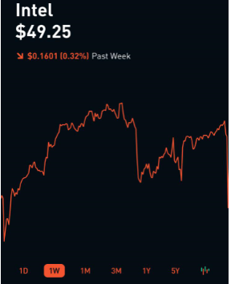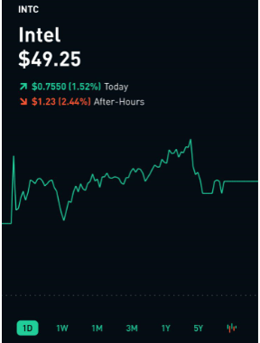

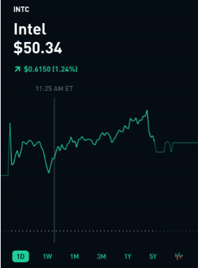



***Grouping*:**

The stock information regarding a stock are grouped together according to the categories. The miller’s magic number has been followed for the feature grouping in each company.

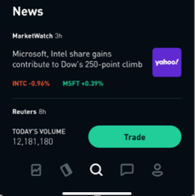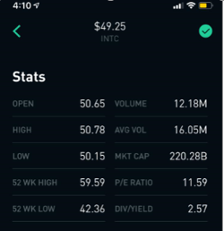



**The Bad:**

***Feedback*:**

Feedback implies that there shouldn’t be any confusion about whether the initiated task was successful or not. The user is not notified when they try to save a stock or add it to the watchlist.

***Limit cognitive load and complexity*:**

Lot of information is displayed on stock page which might be overwhelming for a novice user.

**Buy/sell**

**The Good**:

***Affordances*:**

Affordances can be explained as possible actions a user can perform and how well an interface can communicate how it should be interacted with. The user has the option to choose their order types.

***Mapping*:**

When a user gives input for the quantity of shares, the software automatically multiples according to the number of shares entered and displays the total amount the user pays in dollars. Additionally, relevant graphs are displayed against the order types.

***Visibility*:**

The user has the discover option to look at different orders when they are on the Buying page. They can change the order types if they want to change.

**The Bad**:

***Mapping*:** 

When a user clicks on the Buy option, the price of the stock at that time is considered. And if the user delays and there is a price variation, the price remains the same from the time the user clicked on Buy.

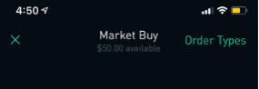

***Visibility*:**

The available balance displayed on the page doesn’t specify whether the balance amount is after purchasing the stock or before purchasing.

**Account Settings**

**The Good**: 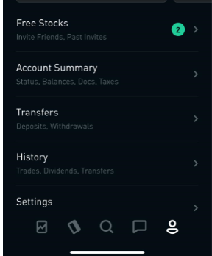

***Grouping***:

Grouping is used to separate similar information. There are different sections in this feature and each of them are grouped under respective sections which makes it easy for users to understand.

***Consistency and flexibility***:

The user can update their information using the app. They can change the name on their profile, they even have access to change their security settings, and can manage the number of devices they are logged in with.



**The Bad:**

***Duplication*:** 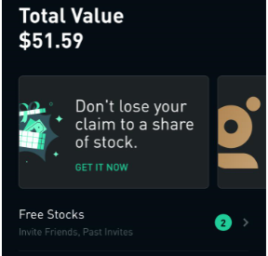

The sections information is repeated on the page. The free stocks and the display with an image related to the free stocks is repeated as shown in Figure. This creates confusion to the users.

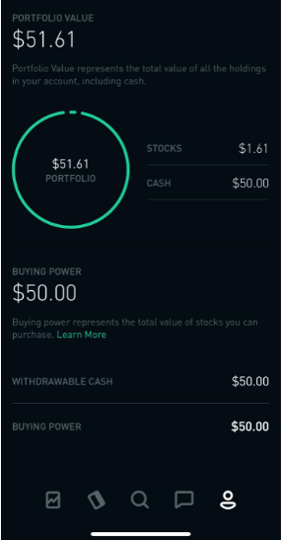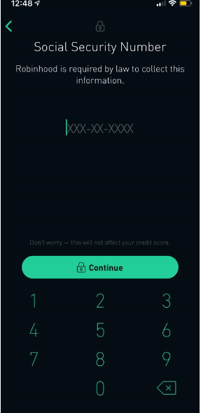



***Limit cognitive load and complexity*:**

Excessive information is displayed when a user wants to know about the account details and portfolio, which makes it complex for the user to understand. The information provided is more complicated than necessary.

***Flexibility*:**

Users can only login to the app after providing all the necessary information. They can access the app only after adding their SSN and banking account details. This makes it difficult for users who want to see only the patterns and not trade.

**Task Evaluation**

**Task: Signup to Robinhood app as a new customer**

Evan is a professional, curious of investing his earnings to save for the future. Evan had heard about the Robinhood app that it allows users to trade in stocks and cryptocurrencies commission free, so wanted to try out the app to help him and get started with investment. Since he is using the application for the first time, he is unsure whether the app will satisfy his needs or not. The app on the signup screen lists some of the essential features the app offers and the functionalities that user can achieve by using the app as shown in the below screens.

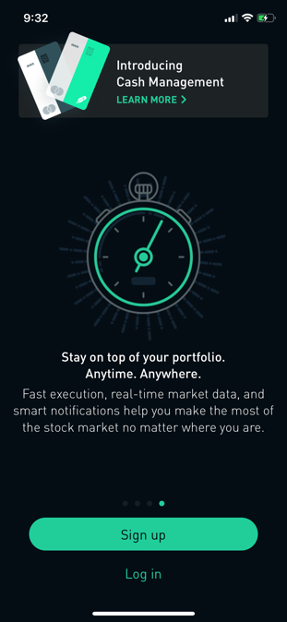



The signup button is designed according to the **Fitz law** as the button is larger in size and also an easy target to hit for the user. The sign-up task is a progressive process where on each screen the user is asked a specific information.



This approach requests user information in increasing order of the criticality of the data. Starting from email address, first and last name, mobile number and then the social security number. Furthermore, the data that each of the screen demands is not that large and grouping the fields on a single screen would have presented user the task of filling all the necessary information at once.

Currently, as the requested data is spanned out to multiple screens, user goes on filling the data as requested until all the sign-up screens are accomplished. During this process, user is unaware of the amount of task that is completed and what amount of the task is left over. A proper **progression** **feedback** mechanism such as a percentage or milestone bar will help the user to identify the task progress effectively.

**Task: Buy a stock on Robinhood app**

Evan after signing up for the app, now wishes to buy a few stocks. He looks for the search box and starts typing “*amazon.com*” and gets auto suggestions for the same. Auto suggestions are particularly very helpful in this scenario as there are tons of stocks and it is difficult for the user to remember the exact name of each of those. On searching the stock, the user is presented with graphically and visually appealing charts and statistics pertaining to the stock. There is proper grouping of statistics, news and line graph pertaining to the stock which assists the user whether he/she should buy that stock.



The “buy” button is easy target to hit as it is at the bottom right and larger in size (Fitz) law. Furthermore, the color of the “buy” button flips between “red” and “green” depending on whether the stock price went up or went down on the current day. The “red” color is somewhat misleading as it is generally used in case of errors or dangers. Even if the stock price went down the user might still want to buy the stock as it could be the best price. Hence a constant color of the buy button will help the cause.



On the buying page we have **affordances** in different order types the user can choose from. Furthermore, the app doesn’t present a one click buying option. Furthermore, there is no “Submit order” or “Buy” option on the page and user here might me confused or could not **recognize** that after the Review button there is finish order option. Moreover, the user inadvertently has to review the order before buying even if he/she doesn’t want to do so.

The buying screen presents information about the funds available with the user, mentions the total payable amount and stock price in dollars maintaining consistency. Furthermore, the buying screen presents appropriate **mapping** in two scenarios. One of them is continuous updates the stock price to the current price as it changes and the second is when the user updates the quantity of stock that he/she intends to buy the stock price, the multiplier updates the final payable amount. The app changes its theme to dark in the night and to a lighter tone in the day to make user easily spot the content on the screen, thus satisfying the principle of **consistency**.

# Comparative Study

The applications that we have chosen for the purpose of this comparison are

1. Robinhood
2. Fidelity
3. Ameritrade

This report consists of a comparative study of the three applications chosen above and provides the reader with detailed insight. For the purpose of this study, we have compared the UI elements and the overall interface of three different pages. The three scenarios considered are checking the price of individual stocks, the news page provided within the app to check the latest news related to one particular company and the watchlist page of all the favorite stocks the user has added.

For the purpose of this study, we have also compared the task flows of three such use cases of buying and selling a stock, adding a stock to the individual's watchlist and Searching for a specific stock and see the latest news regarding the same company.

**User Interface and the UI Elements:**

1. ***The Stock price page*:**

The stock price page of the Robinhood app is more visually appealing when compared to the other applications. The stock price is dynamically mapped to the price counter in the top of the page when the number goes up if the stock price goes up and the color changes to green and on the other hand, when the stock price goes down, then the number is animated so it looks as if the number goes down too and the color changes to red. The stock price page in Ameritrade is much blander without any color-coded UI elements with a white background. And the graph showing the stock price graph is static without any sort of mapping. Even the information provided by the app in regard to the news and the stock price is overwhelming as all the information is crammed into a single page with a tabular view. When it comes to the Fidelity mobile app, the stock price page is fairly simple with limited features such as buy a stock and/or add it to the watchlist. All the other features are categorized into groups and menus so that the user is not overwhelmed with so many features. As the user clicks on the related section, that particular section expands to show the user a detailed view.

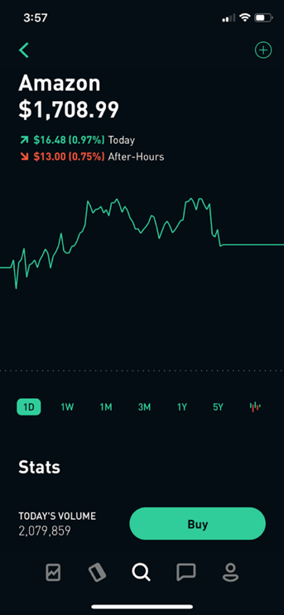

1. ***News Page*:** 

The news page and the search page are integrated in the Robinhood application. The News aspect is grouped under Recent News subheading and all the news is grouped together into one section. The latest news regarding the financial market is under this section and the user can click on any of the news articles to get a detailed view of the news with description. Whereas in Ameritrade, for the user to get to the news section, it is a complicated multi-step process. The user first needs to search for a stock and then the user needs to click on the News tab for the user to see the latest news related to that company. The news page in the Fidelity application resides on the homepage of the application like the like found in Robinhood. But in Fidelity, the news is loaded once the app is loaded and is not dynamic so there is no mapping as such and to access more news, the user needs to click on the three-dot menu and then click on View more news which then takes the user to detailed page which contains all the latest news.



***3****.****Watchlist*:**

The watchlist is located right on the homepage in our Robinhood application. The user can add a specific stock into their own watchlist to add them to the list of their favorite stock and can monitor the stock price right from the homepage. The watchlist is also mapped to the user’s portfolio so he can monitor his net worth by calculating the current stock price with the number of stocks that he owns for the particular company. In the case of Ameritrade, adding a stock to the Wishlist and the viewing the Wishlist is as simple as it was in the case of Robinhood. But the UI elements are incomprehensible. For example, in order for the user to add a stock to his Wishlist, the user needs to click on the ‘+’ icon on the home screen and search for the symbol he needs to add. But there is no label associated with the ‘+’ symbol so amateur users might find it hard to deduce that the ‘+’ is to add a stock to the watchlist. The watchlist page in the Fidelity app is similar to the one in the Ameritrade app where the user is overloaded with so much information which can be useful for advanced users but for Amateurs and Novices who do not possess much knowledge in the fields of stock market might find the watchlist a little overwhelming.



**Task Flows:**

The task flows that are to be compared for the purpose of this study are

1. Buying a stock
2. Adding a stock to the watchlist
3. Changing a password

For this comparison, we will be comparing the number of steps and how ‘easy’ are the above features for the end-user and the comparison is depicted pictorially.

1. ***Buying a Stock*:**

In order to buy a stock in the Robinhood app, the individual has to search for the respective stock from the search tab(signified by the magnifying glass) and enter the quantity of stock that the user wants to buy and then there is an additional step where the user can review his/her order and then proceed to buy the stock which is then added to his/her portfolio. The whole process takes 4 steps. In the case of Fidelity, to go to the search section takes the user two steps so the total steps taken to buy a stock become 5 and same is the case with Ameritrade.A screenshot of a cell phone



1. ***Adding a stock to the watchlist*:**

In the case of Robinhood, to add a certain stock to the watchlist, the individual needs to go to the search screen using the Navigation bar on the bottom. Following that, the user needs to search for the stock he/she wants to add to their watchlist and click on the ‘+’ icon on the top right next to the Stock name. In the case of Ameritrade, after the user clicks on the ‘+’ icon in the bottom navigation bar, the individual has to search for the stock and the stock is added. In Fidelity, the process is a complicated one. The user needs to swipe from the left to see the menu and then click on the watchlist. Then he/she needs to search for the symbol to be added and then the stock is added to the watchlist.



1. ***Reading the news related to a company*:**

In the case of Robinhood, for the user to read the news from a company, the individual needs to the first search for the company and click on the symbol and he/she will be redirected to that particular stock page. The user then needs to scroll down to find the section with the title news and from there, the user can read through the news for a particular company. In Fidelity, the number of steps is similar where the user needs to search for a stock and then scroll down to find the news section. In the case of Ameritrade, the number of steps is similar to the point of searching for a company and going to the particular stock page. After that, the user needs to swipe twice across the screen to get to the news tab. A screenshot of a cell phone



**Availability**

This section of the comparative study takes a look at the availability and the ubiquitous nature of our application i.e., the number of platforms that the application is available on.

1. *Robinhood*: Robinhood is available as a mobile application only and not as a desktop application or a web application. It also has a smartwatch companion app that has a limited feature set such as the current portfolio value and the stock prices of the watchlist.
2. *Ameritrade*: This has a wider set of platforms that the application is available. It is available in all major platforms as a desktop/mobile app as well as a web app that can be used for trading in the browser.
3. *Fidelity*: Fidelity also has a mobile app and a desktop app, but it does not have a smartwatch companion app.

|  |  |  |  |  |  |  |
| --- | --- | --- | --- | --- | --- | --- |
| **Application** | **IOS** | **Android** | **macOS** | **Windows** | **WearOS** | **Android Wear** |
| Robinhood | ✓ | ✓ |  |  | ✓ | ✓ |
| Ameritrade | ✓ | ✓ | ✓ | ✓ | ✓ | ✓ |
| Fidelity | ✓ | ✓ | ✓ | ✓ |  |  |

# User Profiling:

Robinhood ended up popular by promising no stock trading costs and offering cryptocurrency trading such as Bitcoin, Ethereum and Litecoin. Robinhood's consumer base has grown to over four million when you consider that its founding in 2013, with an average age of 32 calculated in September 2017. For its 6 million users, the clearing system means decreased fees, as well as better client aid and overall experience of shopping and promoting the stocks. Although older generations can also invest in retirement, Robinhood members, 78% of whom are under the age of 35, choose to both develop their financial savings and improve product relationships – just as they do on Instagram and Twitter. According to a Robinhood’s user information database median age of Robinhood users is 28. The Robinhood app is used by successful users 10 times a day on average. Robinhood users ' common age is 28-41, and most of them use the app to buy their first stock. We discovered that most of the users of the app use cash to save, according to the creators of Robinhood, Vlad Tenev and Baiju Bhatt. Such money will normally be used for coffee or other luxury products, but the money is now being used to invest in Robinhood. That said, most of the app's users appear to be college students and older who have only a few hundred dollars to invest.

**Personas**:

Three User Persons are developed to explain the different objectives and responsibilities among different users. Such personas are created on the basis of our knowledge of Robinhood users, the content present in Robinhood user profiles, as well as a survey we generated that told our awareness of the different ways of using Robinhood individuals.

|  |  |
| --- | --- |
| **Person 1:**  https://lh5.googleusercontent.com/WYQujwBVgKcYkntUQZNxcbyVOTyXpzN3rMvQoQU0bUuc4GD2NLzC0AqaotxFo06-s0hN4F1uK7PCs_be0iMvZW0-vIZJt-MgH4h6eQOQbr4ZPBlZaaZDVUEfIWIyYThsoRizcNQ   * Aven is a novice user of Robinhood * His hobby is stock trading * He is a student | *Tasks*:   * Buy the stocks * Sell the stocks * Save few companies to the watchlist |
| *Goals*:   * Buying the stocks frequently with price of less than 10$ * Selling the stocks for profit as soon as there is an increase in the stock value * Save the companies to the watchlist to make a decision |
| *Frustrations*:   * When they cannot find a stock, they are looking for * When the buying and selling instructions are not clear |

|  |  |
| --- | --- |
| **Person 2:**  https://lh3.googleusercontent.com/c4HYd0Mljnw6mhPthPiSmHhChh3gwCduu_rYiSpXEd7JM2dmrOolQmIDTelrLZN4igIv1nvNOglbs-BQAEDvLor08B3BgOjY0x3C5-VNrP3RxcfDuhLycHFUXax-40_yMQc01zs   * Nick is a experienced user, loyal to Robinhood for 3 years * His main source of income is through stock trading | *Tasks*:   * Limit order * News * Announcements |
| *Goals*:   * Buy and sell securities at a certain price in the future * Watch news in the app to know the current information * Read the announcements to know the changes in the app |
| *Frustrations*:   * When there is a change in the app and it is not mentioned in the announcements * When the price of the stock never reaches the limit specified * When is news in not up-to-date |

|  |  |
| --- | --- |
| **Person 3:**  https://lh5.googleusercontent.com/gIsJuTz-4zaU41w2MsbbnQQOegL_OnOIdZXSqdyJuN0qlUH1YtLWrGHV4L-D8j-op0rHJyj5aTmjBaPDAif_byXADDEONLTU7Osu1CF_OMsbrAVBAd9UAfk17BIC5u9VVl7Va_0   * Catherine is stock broker for 3 years * She does the high-volume trading daily | *Tasks*:   * Buy the stocks of high value more than 100$ * Sell the stocks when there is a huge difference (at least 50$) in the investment and the current price * Market order |
| *Goals*:   * Buying the stocks of companies with good price history * Wait till there is a huge increase in the price of the stock * Buy the stock at the market price |
| *Frustrations*:   * When they cannot find a stock, they are looking for * When the price of the stocks changes while checkout during market order * When the price prediction is wrong |

**Usability Metrics**

The three usability metrics that we will be using for the purpose of our Evaluation are

1. Visually Appealing
2. Easy to use
3. Easy to Learn

***Visually Appealing*:**

For the purpose of evaluation using this metric, we have conducted a brief survey to find out what the end-user thinks about the visually appealing nature of the application.

***Easy to use*:**

Since this is a qualitative metric, it cannot be exactly quantified using the metrics. So for the purpose of this metric, we have taken the time taken for the users to finish a particular task and then compared the same with similar applications. We have also compared the number of steps it takes to finish a certain task in Robinhood and it’s competing apps.

***Easy to Learn*:**

For this metric, we have considered the number of errors that the user makes to figure out a task and how long it takes for him to figure the whole thing out.

**Techniques**

1. **Usability Task Analysis:**

For some of the frequent tasks that user intends to achieve from the app have been analyzed below:

1. **User intends to search the stock/crypto currency price on a particular day or time**

* To understand buying and selling patterns for the stock and study it against potential other stock options the user decides to find out the stock price 2 years back on the day when the company received major funding.
* The user opened the Robinhood app and searched for the stock in the search menu, upon which he/she is presented with a line graph of price changes over a period of time.
* Firstly, the user has to tap on the “5Y” button. And then navigate by moving the cursor over the line graph to find out the price on the intended date as shown in figure below.
* The above process has primarily two usability concerns.
* **Firstly,**

1. Smaller button tap target: Size of interactive elements like buttons should be appropriate to account for people with visual impairments .
2. Our survey showed 6/18 people clicking on a nearby button as opposed to where they intended to click.

* **Secondly,**

1. The user has to swipe all thought the line graph as shown in the figure to check the price on a particular day.
2. On contrary, an additional search box with filters of time and date will allow user to quickly navigate to the stock price on particular date.
3. With the current swiping approach, the user can get only monthly aggregated trends for previous years and there is no available functionality to search for stock trend on a specific day/time as depicting in Fig 36 below.



1. **User wants to get his/her portfolio details:**

* User navigates to account summary to find out the portfolio and total investment done including stocks and crypto currencies.
* Following screen is displayed to the user showing the current valuation of his/her investment.
* The survey showed users wanting to know more information about their investments try to click on the area where for depiction we have highlighted portions of the screen to know more specifics like all investments they hold, quantity of each investment and which particular investment is doing good/ bad.A screenshot of a cell phone

  Description automatically generated
* However, the highlighted portions where user would generally click are non-clickable portions. Furthermore, there is no menu in the app where user can see the above discussed specifics pertaining to user investment.
* The only way for the user to get detailed portfolio detail is to log into website and get the desired information. With most of the Robinhood users being mobile users it is important that such option should be provided to the user even in the app version of Robinhood.

1. **Qualtrics Survey**

A Qualtrics survey was conducted to gauge usability and user experiences while using Robinhood app.

*Figure 37.1*: Qualtrics Survey

**Tools used for Evaluation**

**Qualtrics:**

Qualtrics survey platform is primarily used for taking online surveys. The quick survey builder functionality allows to create and share the surveys with the survey participants. After the survey the results can be aggregated and graphically analyzed to understand trends and results.

**Microsoft Excel:**

A Microsoft product that was mainly used in this project for data representation and aggregation by performing aggregation functions on it.

**Draw.io:**

Web tool to model flowcharts, process workflows and design wireframes to analyze and test various scenarios and tasks.

**Screen Recorder and Timer:**

The screen recorder and timer were used to analyze user movement and transition though the Robinhood app. The timer assisted in finding out the time taken to complete a particular task to pin out tedious ones.

## Usability Evaluation based on your Usability Metrics

**Survey:**

The survey first gathered primary demographic information and was shared through social networking apps and websites which possibly limited the reach to a youthful group. 77% of the contributors were between the ages of 24 and 34. Most of the contributors have been students, 54%. These consequences would possibly have been because of the approach of circulation. As the survey was held in the USA, the place we have fast net speed, many people prefer to use the mobile application over the website. The survey confirmed that most participants use applications for buying and selling the inventory market (40%) and Stock brokerage (36%). The majority of the contributors used Robinhood (70%), Betterment (10%) and Fidelity (20%).

**Q1: What do you like the most about Robinhood?**

31% like using Robinhood because it's a free app, 24% because it gives stock value history and 24% because of the functionality it offers. Yet, as it was visually appealing and user-friendly, only 10 percent of Robinhood users found they continued to use Robinhood. It conveys that users enjoy the functionality of Robinhood, but it could boost usability.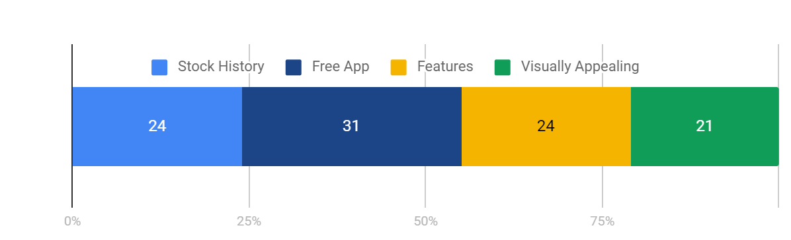

*Figure 37:* Favorite Robinhood app characteristics

**Q2:** **What do you dislike the most about Robinhood?**

33 % Robinhood users hate that trades appear to be routed to generate payment for order flow, not best price. 26% weren’t sure what all Home Screen menu tabs meant, and the rest did not like that, there is no option to un list companies from the watchlist on the watchlist screen.

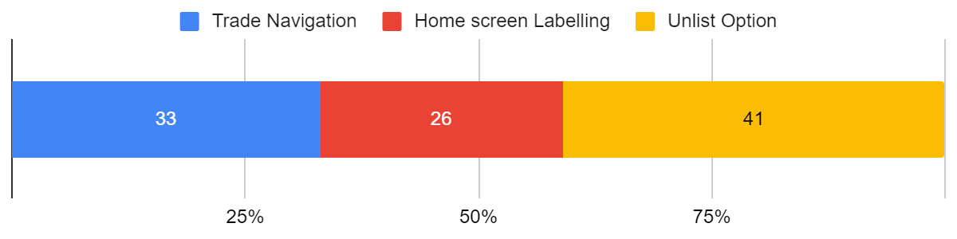

*Figure 38:* Characteristics to dislike in Robinhood

**Q3: Participants were asked to rate on a scale from 1 to 10 how much they liked Robinhood’s ease of selling and buying stocks and whether they found Robinhood user friendly and if it has visual appeal.**

Participants appreciated buying and selling features that Robinhood offers and gave a 7.8 score overall to this measure. Yet participants did not feel very good about how user-friendly or visually appealing Robinhood was, giving less than a 6.5 score to those elements.

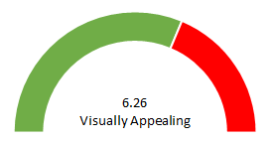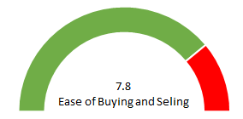

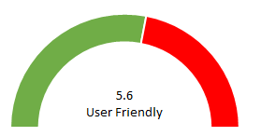

*Figure 39:* Robinhood ease of use functionalities comparison

**User​ ​Study.**

The following are the results and insights from the user Study.

**Task​ ​1: ​ ​Select a Company, buy its stocks.**

*Is this task easy to learn how to do?*

The mission was accomplished by 8 students. 2 They couldn't finish the job, they couldn't figure out the purchase option. Such difficulties indicate that learning how to do this task isn't very easy.

*Is this easy to use?*

Of the eight participants who completed the mission, all took over 40 seconds to complete. It takes 4 steps to complete this task and in so many steps only one person completed the task. We concluded that this function is not very easy to use as it took longer than needed and participants took additional steps to complete the task.

**Task​ ​2: ​ ​Add the companies in watchlist**

*Is this task easy to learn how to do?*

This assignment was accomplished by all 10 participants. When performing this mission, one student made an error. Since only one participant made a mistake, we found that learning how to add companies to the watch list is fairly easy.

*Is this easy to use?*

The mission was accomplished by 10 of the participants over 30 seconds. To complete this mission, it takes three stages, six participants completed in three steps, two took four steps and two took six steps. While they did not make several faults and they understood how to perform the task, users often took a while to finish the given tasks, this mission could be easier by incorporating some tag data and making it more evident, so individuals could perform this mission more quickly.

**Task​ ​3: ​ ​Browse for a company**

*Is this task easy to learn how to do?*

Every participant fulfilled this task and there was no mistake made by any individuals.

*Is this easy to use?*

4 took longer than 15 seconds with a max of 25 seconds. Completing this task needs 2 steps, 3 have done so, and the other three have taken 4 steps to accomplish the task. Half of respondents accomplished this task very rapidly without any complications, the another half required one more move than required, however this feature was quite simple to use overall.

**Summary:**

We are able to obtain information out of these usability tests on our three usability targets.

***Visually Appealing*:**

We found that respondents did not find Robinhood quite visually striking, respondents rated Robinhood 6.25 out of 10 to be visually appealing, and only 10% of respondents use Robinhood based on their aesthetic qualities. We assume that an application for financial product should be visually attractive and is a place where Robinhood can develop.

***Easy to Learn*:**

Robinhood has a few complicated tasks with which members strive to learn using the software. Robinhood itself is not hard to learn to use, but some activities were not easy to understand how to use. The primary task is indeed not simple to find out which stock is purchased and sold, 4 of our 10 respondents made mistakes during this task. This is a task that Robinhood should evaluate and redesign.

***Easy to Use*:**

While respondents in the poll did not see Robinhood as a simple-to-use program, they only have a 5.6 score, which is remarkably low. Ultimately, respondents are able to fulfill tasks comfortably in the user study. While most of them took just as much as necessary steps. This could imply that those tasks that participants fail with, like locating the option of purchasing, can influence their general perception of the software. During the comparative study, the Ease of Use metric was also examined. Robinhood needed an additional step in two of the three activities compared to similar applications. Robinhood would benefit from having their software less complicated in addition to being able simple for participants to use the program as a whole.

**Usability enhancements**

The study identified three important areas where we think the usability of the Robinhood app can improve over its already thriving user interface and user experience. The recommendations are as described below:

1. **Soften cognitive impetus on the user:**

* On the stock details page a novice user is presented with lot of information to work upon. The information categorically groups information as line graph, stocks stats and news pertaining to the selected stock.
* The user has primarily arrived on the screen to either look at current or historic price of the stock or to buy one of them.
* Providing news, stock company information and updates regarding to the stock only when demanded by the user would be good design approach. This can be achieved by having a tab for news separately which will thus avoid cluttering of too much data on the screen. Putting prominently used cases and workflows on the screen and revealing other desired information only when requested will help reduce complexity of the application.







1. **Stock screen time frame selection buttons are too small (Fitz law):**

* The survey indicated that 8 out of 14 people had problem selecting the buttons for past time slots.
* The size of interactive elements should be well thought of and there should be consideration of people with visual impairments.
* The smaller the buttons it requires more effort on the part of the user which could lead to dissatisfaction and increase of cognitive load on them.
* The current button orientation is well arranged for the screen and the enhancements would be to make the button considerably larger and allowing other select options using a scroll bar.
* As mentioned in iOS design principles [3] there is the guideline specified for the button targets to be of size of at least 46 points.







1. **Provide a search tool for studying historic prices of the stock:**

* Currently the user has to search swipe through the entire line graph to find the price of the stock on current day or time.
* This is a tedious process especially when searching for the stock price five years back.
* The user has to first sect the tap target of “5Y” and then swipe all way through on the line graph showing stock price trends to find the stock on the specified search criteria.
* Moreover, the price of stock is also aggregated on monthly basis as the average price and user is unable to view the price of stock on a particular day and time some years back.
* As a solution, a search box should be added additionally which will accept the search parameters and provide the user with necessary data.
* The search box should not be visible at all times on the screen to avoid utilizing the screen space. On contrary it should be popped on the screen when user requests for it by clicking/ pressing on an interaction UI element.

**Conclusion**

In conclusion, Robinhood is a great app primarily used to deal in stocks and cryptocurrencies all commission free. The evaluation highlighted a number of areas where Robinhood does an excellent job with respect to usability and user interface design patterns. Robinhood provides feedback on all important areas of user interaction and state alterations in the app. This includes appropriate error messages, help option in form of pop ups on every screen and next to stock trading jargons. For the novice user or the user visiting the app for the very first time the app presents a guided tour of the app highlighting portions of the screen which could be of importance to the user. Furthermore, Robinhood presents great use of mapping, affordances with great icon consistency and visibility. For instance, the app changes its theme to dark during the night and to a lighter tone in the day to make app use efficient. The app also presents user personalization especially with respect to language, theme, and stock suggestion preferences for the user.

Some of the major concerns include the app complexity and it being cognitively intensive over a novice user. For instance, the stock details page presents too much information on one screen with scroll option. For an experienced user the information would be of great sense and importance but for a beginner, he/she will get intimidated with the complexity. Furthermore, a greater number of steps are used to accomplish a commonly used tasks on the app. This include buying a stock which require accepting and reviewing a lot of things before actually the user can submit an order. With respect icons and buttons, though they are consistent they haven’t been built keeping in mind the use of app by slightly visually impaired people. For instance, the button for looking the prices of stock are too small and as observed in the survey visually impaired users found it difficult to click on the button in one go without hitting nearby actions items.

Overall, most of the essential components of the app are quite easy to use which was evident in user surveys. As compared to other applications users found Robinhood scoring high on most of the aspects and functionalities. The app, furthermore, works well on all the platforms including IOS, android and windows. Though with some usability updates as suggested above in the report the app will seamless perform on all usability and user experience fronts.

**What we learned from the project**

As a team before starting we were not sure how a well-established application in the market can still possess some usability and user experience issues. After applying the usability principles that we grasped during the lectures and comparing it against the Robinhood app we found several fronts where the app did exceedingly well whereas failing on rest. Throughout the project we understood the formal procedure to evaluate any application using the tools and techniques that we learned in the project. The team was able to infer and spot how granular incorporations in design principles could have profound effect on usage. As in the project we interviewed people and took surveys to understand their view over an application, we could uncover different perspectives which also needed attention. As software developers we understood the importance of making a human centered design approach against a purely functional approach. In the project we were able to spot usability metrics and formulate a usability evaluation for the project to compare it against rival competitors.

Furthermore, from the evaluation perspective, the team understood how the usability decisions have to take considering several factors including different user and profile personas against incorporating only a targeted audience. Surveys play an important aspect in interface and task evaluations. More diversified the personas are used in the survey more perspectives are uncovered. Understanding and studying Robinhood app made us understand how a successful and a near user friendly app uses mapping, affordances, icon consistency and visibility with appropriate feedback presented at important steps in the application to guide and assist the user. As a team we worked collectively to research and formulate our findings instilling in us the importance of teamwork.

**References**

[1] Song, L., & Wen, F. (2014, August). The Human-Computer Interaction Design and Research of Virtual Experiment. In *2014 Sixth International Conference on Intelligent Human-Machine Systems and Cybernetics* (Vol. 1, pp. 50-53). IEEE.

[2] Chao, G. (2009, March). Human-computer interaction: process and principles of human-computer interface design. In *2009 International Conference on Computer and Automation Engineering* (pp. 230-233). IEEE.

[3]<https://developer.apple.com/design/human-interface-guidelines/ios/overview/themes/>

[4] Fu, X. (2010, November). Mobile phone UI design principles in the design of human-machine interaction design. In *2010 IEEE 11th International Conference on Computer-Aided Industrial Design & Conceptual Design 1* (Vol. 1, pp. 697-701). IEEE.